Create HTML Pages

|  |  |
| --- | --- |
| Assignment Date | 18 November 2022 |
| Team ID | PNT2022TMID31303 |
| Project Name | AI-Powered Nutrition Analyzer For Fitness Enthusiasts |

* We use HTML to create the front-end part of the web page.
* Here, we have created 3 HTML pages- home.html, image.html,imageprediction.html, and 0.html.
* home.html displays the home page.
* image.html is used for uploading the image
* imageprediction.html will showcase the output
* 0.html is to showcase the result. It tells the action to be performed on imageprediction.html while showcasing the result.

**For more information regarding HTML**

[:https://www.w3schools.com/html/](https://www.w3schools.com/html/)

* We also use JavaScript-main.js and CSS-main.css to enhance our functionality and view of HTML pages.
* Link [:CSS , JS](https://www.w3schools.com/css/)

Home.html looks like this



image.html

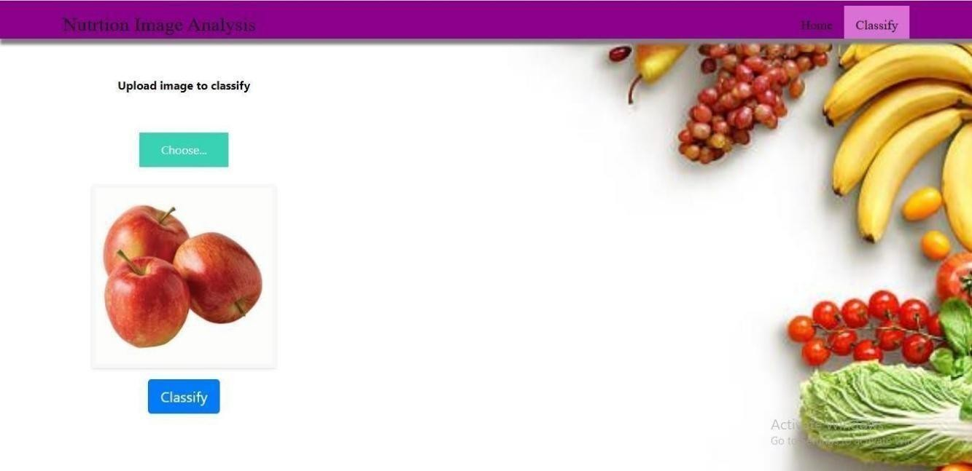

Imageprediction.html

